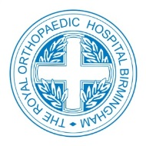

The Birmingham FRCS Tr. & Orth.
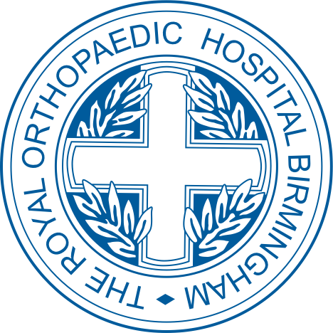
Revision Course
Royal Orthopaedic Hospital NHS Foundation Trust

Across three days, the Royal Orthopaedic Hospital FRCS revision course will include an intensive mix of lectures, clinical examinations and VIVA skills, delivered by a highly regarded faculty from across the West Midlands.

Course Director: Mr Khalid Baloch, Consultant Surgeon, Training Programme Director

Dates: Wednesday 9th, Thursday 10th and Friday 11th January 2019

Venue: The Knowledge Hub,
The Royal Orthopaedic Hospital NHS Foundation Trust,
Bristol Road South,
Northfield,
Birmingham,
B31 2AP

Times: Wednesday 9th January - 8.30am - 5.15pm (tbc)
Thursday 10th January - 8.30am - 5.00pm Course meal on the evening (tbc)
Friday 11th January - 9.00am - 4.30pm (tbc)

Registration Fees: £500.00
Maximum of 18 candidates to allow high quality candidate experience

To reserve your place on the course, please contact the following:

David Richardson: david.richardson2@nhs.net
Brett Ellis: brett.ellis@nhs.net
Laura Jones: laura.jones67@nhs.net
Or telephone: 0121 685 4026
